Name: __________________________________________________________ Date: _______________
Signature: ________________________________________________ Date of Birth: _______________
Gender: ____ Address: __________________________________Social Security #:_________________
How would you like to pay for your care? (Circle all that apply): I will pay myself (Cash, Check, or Credit) Private Insurance: ____________ Medicare Active No Fault Case Active Worker’s Comp Case
Phone Number: _________________________ E-mail address: _________________________________
Work Phone #: _____________________ Emergency Contact: _________ Phone #: _________________
Occupation: __________________________ Employer: ______________________________________
Explain the reason for your visit: _________________________________________________________
When did your pain begin? ______________ What were you doing? ____________________________
Did you go to the hospital for this injury? ___________ If so, when? ____________________________
Since your symptoms began, have they gotten better, worse, or stayed the same? _________________
What treatments have you received for this condition? _______________________________________
Have you had these symptoms before? ___________ If so, how long ago? ________________________
Explain any medical care that you are currently receiving for any other conditions that you may have: _____________________________________________________________________________________
Do you drink alcohol? __________ If so, how much? __________ drinks/week for_____________ years
Do you smoke cigarettes? ___________ If so, how much? __________ pack/day for ____________ years
Have you experienced any recent fever/chills or unexplained weight loss or incontinence?_________
If yes, explain____________________________________________________________________
Past Surgeries: #1 _______________________ year: ______ #2: ____________________ year: ______
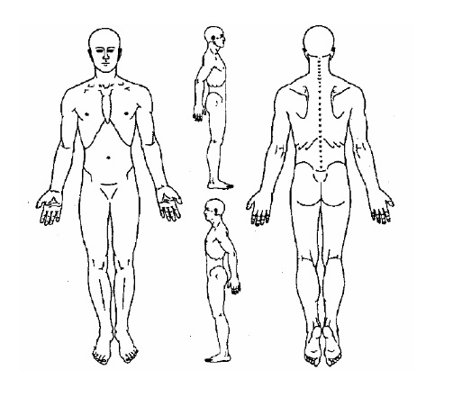
List any serious medical conditions that run in your family: ___________________________________

Mark on the diagram to the right where you are feeling pain and check any boxes that apply to this complaint
Pain
Spasm
Numbness
Tingling
Throbbing
Aching
Other: _____________________
Indicate anything below that improves these symptoms  Nothing helps Stretching  Indicate anything below that improves this condition  Indicate anything below that improves this condition  Rest Lying down  Indicate anything below that improves this condition  Indicate anything below that improves this condition  Medication Exercise  Indicate anything below that improves this condition  Indicate anything below that improves this condition  Walking Other:__________________  Indicate anything below that improves this condition | Indicate anything below that worsens these symptoms  Nothing Lying down  Bending Temperature Changes  Twisting Sneezing  Lifting Sitting  Standing Coughing  Other:________________________________

Informed Consent Release

I hereby request and consent to the performance of chiropractic adjustments and other chiropractic procedures, including physical exam procedures and various modes of physical therapy, on me (or on the patient named below, for whom I am legally responsible) by the doctor of chiropractic named above and/or other licensed doctors of chiropractic who now or in the future work at the clinic or office listed above or any other office or clinic.
I have had an opportunity to discuss with the doctor of chiropractic named below and/or with other office or clinic personnel the nature and purpose of chiropractic adjustments and other procedures. I understand that results are not guaranteed.
I understand and am informed that, as in the practice of medicine, in the practice of chiropractic there are some risks to treatment, including but not limited to fractures, disc injuries, strokes, dislocations and sprains. I do not expect the doctor to be able to anticipate and explain all risks and complications, and I wish to rely upon the doctor to exercise judgment during the course of the procedure which the doctor feels at the time, based upon the facts then known to him or her, is in my best interest.
I have read, or have had read to me, the above consent. I have also had an opportunity to ask questions about its content, and by signing below I agree to the above-named procedures. I intend this consent form to cover the entire course of treatment for my present condition and for any future condition(s) for which I seek treatment.
Patient’s Name: ________________________________________________ DOB: __________
Patient (or legal guardian) Signature____________________________________ Date ________
Witness Signature __________________________________________________ Date________
PRIVACY PRACTICES ~ PATIENT RECEPTION FORM
I have received or reviewed the privacy practice notice (3 pages) for Richard D. Coster, DC, and understand the situations in which this practice may need to utilize or release my medical records. I also understand that I agreed to the use of those records when I initially applied for care at this office (my Application For Care) on my first visit, whenever that may have occurred.
I understand that this office will properly maintain my records, and will use all due means to protect my privacy as outlined in this privacy practices statement.

______________________________________________ ________________
Patient (or legal guardian) Signature Date

